**EXPERIMENT NO:2**

**INSTALLATION OF LINUX**

Step 1: Open VirtualBox and click on the New button.

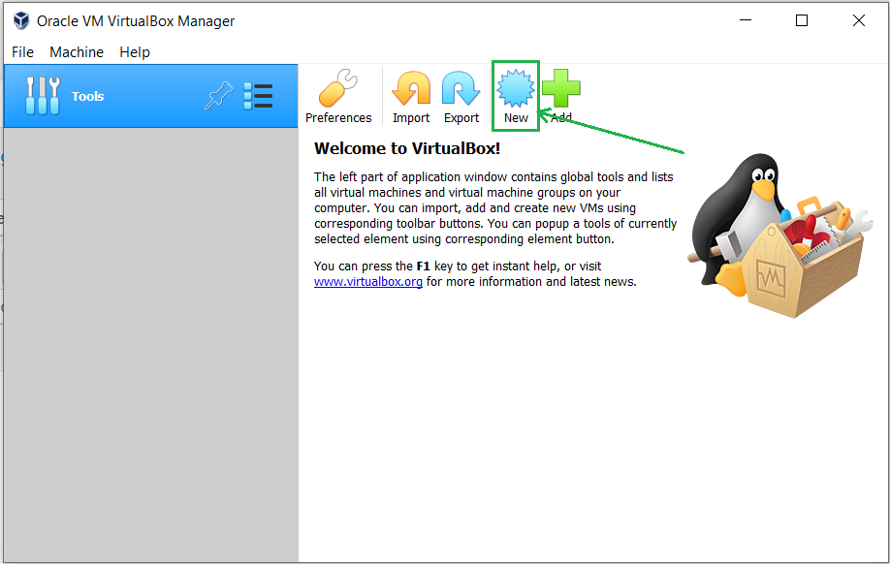  
Step 2: Give a name to your Virtual Machine and select the location for it to install.  
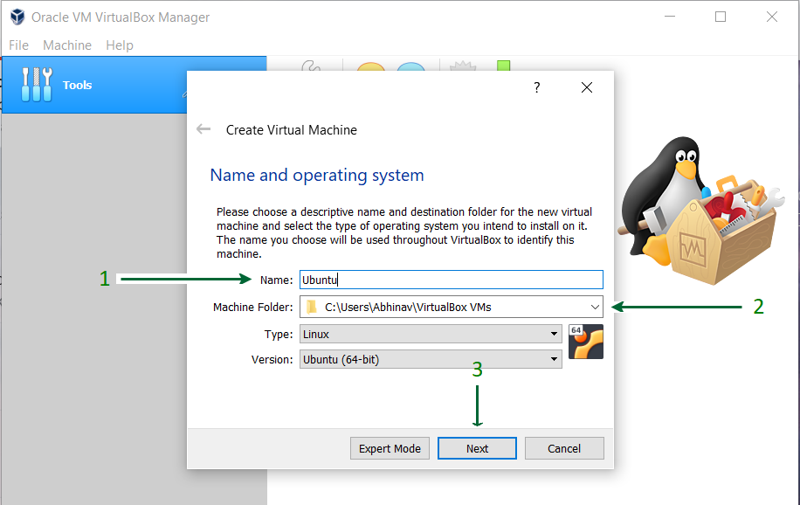

Step 3: Assign RAM size to your Virtual Machine  
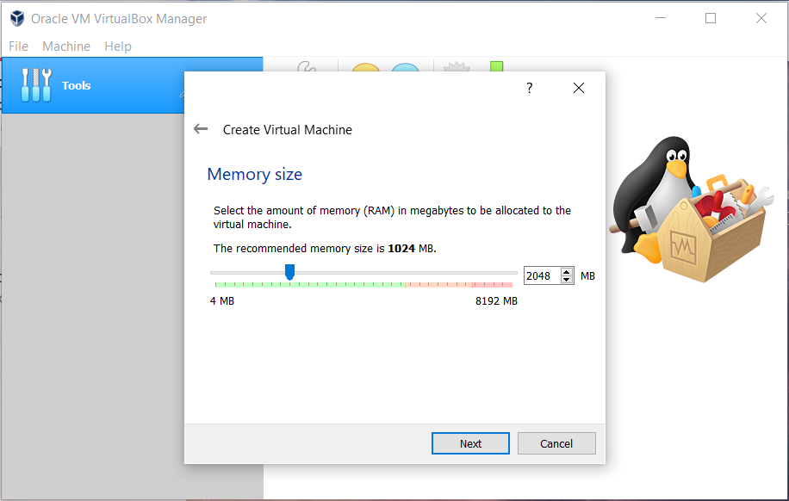.  
  
Step 4: Create a Virtual Hard disk for the machine to store files.  
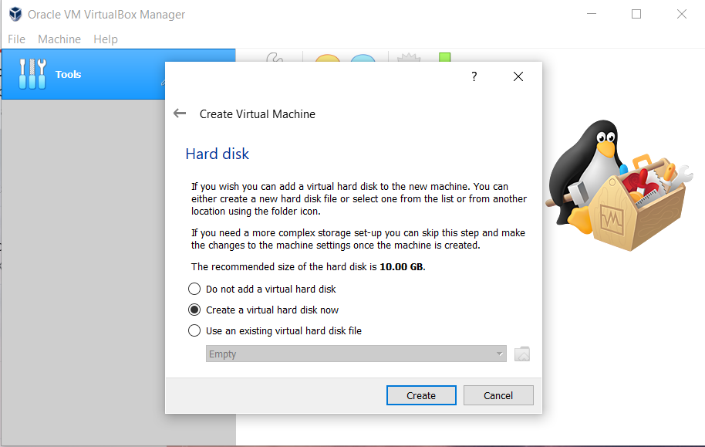  
Step 5: Select the type of Hard disk. Using VDI type is recommended.  
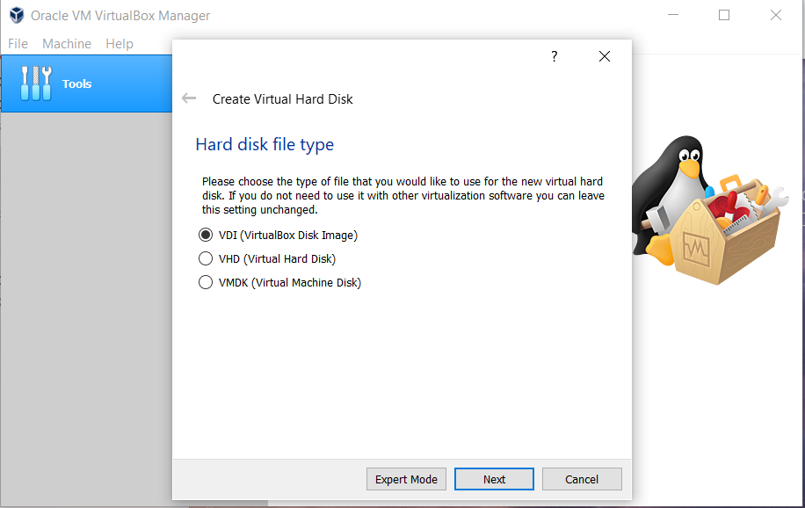  
  
Step 6: Either of the physical storage type can be selected. Using Dynamically allocated disk is by default recommended.  
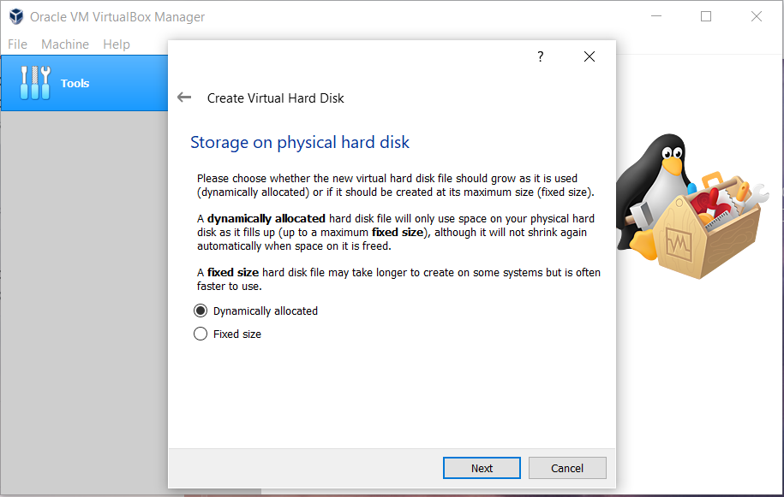

Step 7: Select disk size and provide the destination folder to install.  
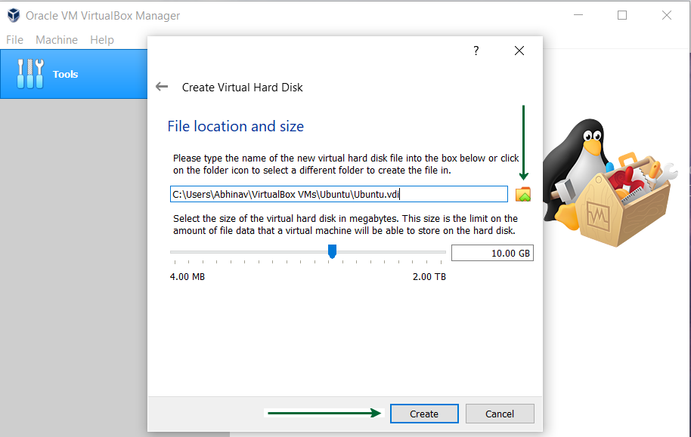  
  
Step 8: After the Disk creation is done, boot the Virtual Machine and begin installing Ubuntu.  
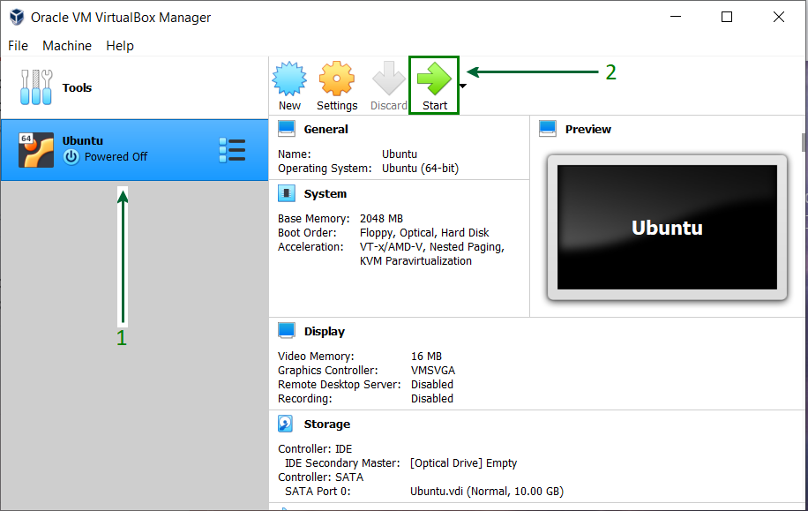  
Step 9: If the installation disk is not automatically detected. Browse the file location and select the ISO file for Ubuntu.  
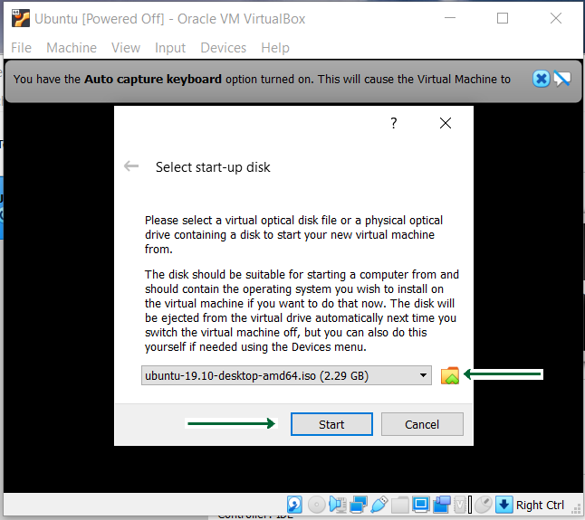  
Step 10: Proceed with the installation file and wait for further options.  
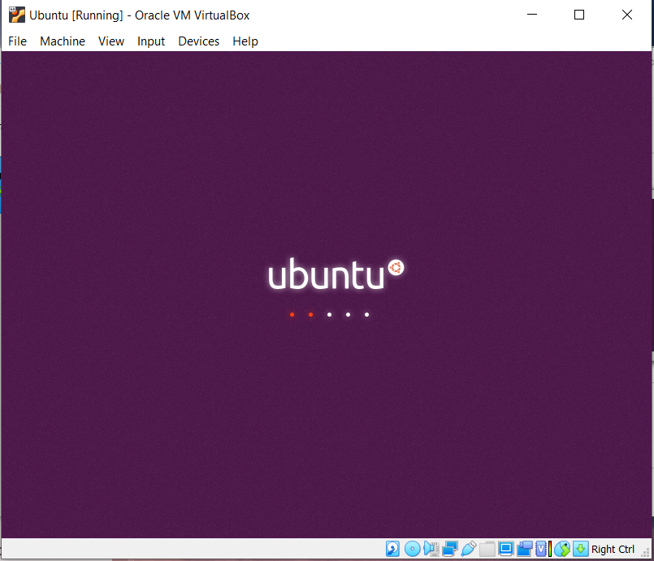

Step 11: Click on the Install Ubuntu option, this might look different for other Ubuntu versions.  
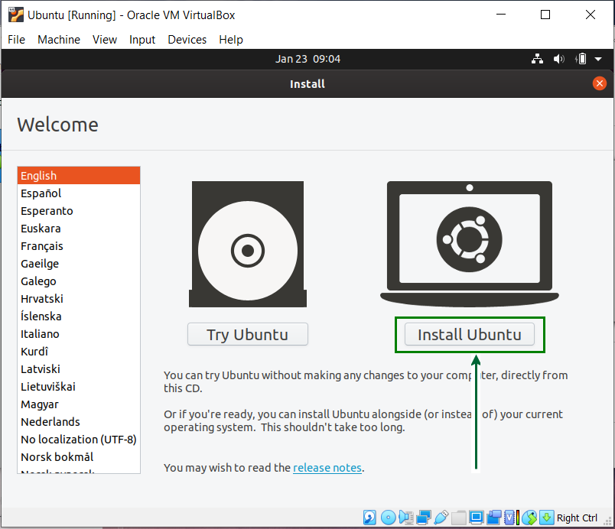  
Step 12: Click on the Install Now button and carry on with the installation. Do not get worried with the Erase disk option, it will only be effective inside the virtual machine, other system files outside the VirtualBox remain intact.  
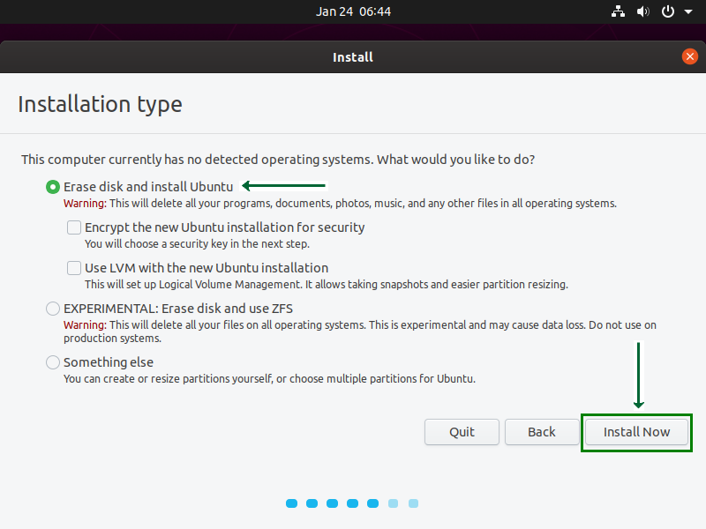  
Step 13: Choose a name for your computer and set a password to secure login info.  
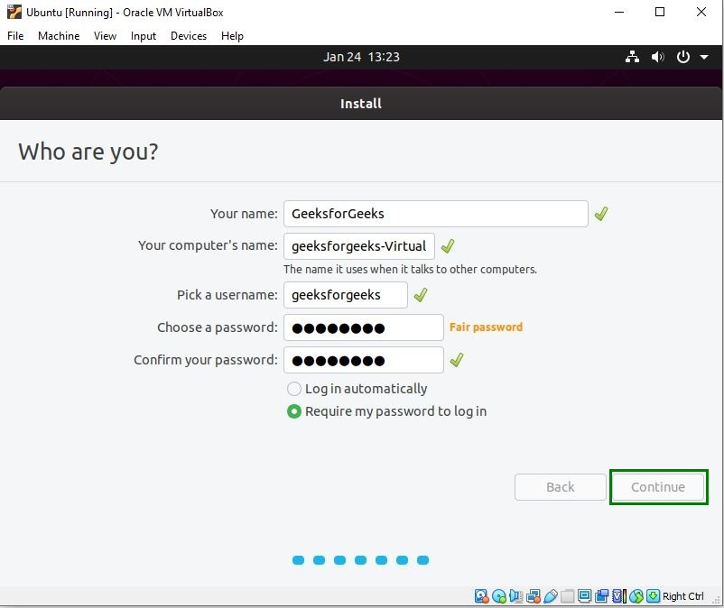  
Step 14: Wait for the installation process to complete.  
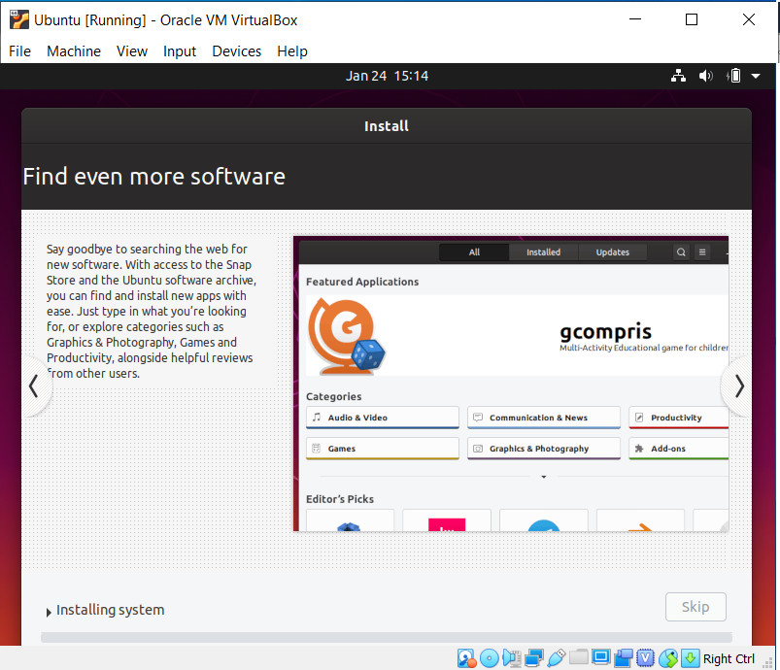  
Step 19: Once the installation process is over, reboot your Virtual Machine.  
